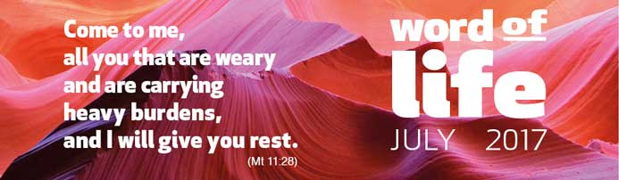

Weary and carrying heavy burdens: these words suggest images of people (men and women, young adults, children and the elderly) who are weighed down in all sorts of ways as they journey through life, hoping the day will come when they can be freed from all this.
In this passage from Matthew’s Gospel, Jesus gives an invitation: ‘Come to me…’
He had around him a crowd that had come to see and hear him. Many of them were simple people, poor, and with little education, unable to know and to follow all the complex religious obligations of their time. What is more, they were saddled with the taxes and bureaucracy of Roman rule, a weight that was often impossible to bear. They were in constant worry and were on the lookout for the offer of a better life.
Jesus, in his teaching, gave special attention to them and to all those excluded by society because they were seen as sinners. He wanted everyone to understand and welcome the most important law, the law that opens the door to the Father’s house: the law of love. God, indeed, reveals his wonders to those with open and simple hearts.
But Jesus invites us too, in this day, to come closer to him. He showed himself as the visible presence of God who is love, a God who loves us immensely just as we are, with our talents and shortcomings, our aspirations and failures! And he invites us to trust in his ‘law’ which is not a burden that crushes us, but a yoke that is easy, filling with joy the hearts of those who live this law. It demands our commitment not to turn in on ourselves, but rather to make our lives an ever-fuller gift to others, day by day.
Come to me, all you that are weary and are carrying heavy burdens,
and I will give you rest.
Jesus also makes a promise: ‘I will give you rest.’
In what way? First of all, through his presence, which becomes more decisive and deep in us if we choose him as the cornerstone of our life. Next, through a special inner light that shines upon our daily footsteps and makes us discover life’s meaning, even when outwardly things are tough. And then if we start loving as Jesus himself did, in love we find the strength to carry on and the fullness of freedom, because the life of God grows within us.
In the commentary of her Word of Life from May 1999, Chiara Lubich wrote:
‘A Christian who is not always striving to love does not deserve the name of Christian. The reason is that all Jesus’ commandments are summed up in one: to love God and love our neighbour in whom we see and love Jesus. Love is not mere feelings but translates into real life, into service of our brothers and sisters, especially those who are close to us, starting from the little things, from the humblest of services. Charles de Foucauld says: “When you love someone, you are in that person in a real way, you are in that person through love, you live in that person through love; you do not live in yourself, you are 'detached' from yourself, 'outside' yourself.” And it is because of this love that Jesus’ light gains ground in us, just as he promised: “To those who love me… I will reveal myself” (see Jn 14:21). Love is a source of light. And by loving, we have a greater understanding of God who is love.’
Come to me, all you that are weary and are carrying heavy burdens,
and I will give you rest.
So, let’s accept Jesus’ invitation to go to him, knowing he is the source of our hope and our peace.
Let’s accept his ‘commandment’ and strive to love, just as he did, in the endless opportunities to do this all through the day: in our families, in the parish, at work – responding to offences with forgiveness, building bridges rather than walls, and putting ourselves at the service of anyone weighed down by difficulties.
Far from being a burden, we will discover that this law gives us wings to soar on high.
Letizia Magri

