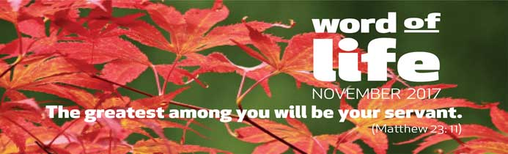
Jesus was speaking to the crowds that followed him, telling them what was new about the way his disciples lived. Their lives went “against the current” in comparison to the usual way of thinking of the time. In Jesus’ day (and today too) it was easy to speak in high moral terms and then not live accordingly, seeking prestige in society and wanting to be noticed, or using others for personal advantage. Jesus asks his disciples to have a completely different logic when relating to others, as he himself had.

The greatest among you will be your servant.
At a meeting with people who wanted to discover how to live the Gospel, Chiara Lubich shared her spiritual experience: “We must keep our gaze fixed on the one Father of so many children, and then consider all people as children of that one Father… Jesus, who is our model, taught us two things that are ultimately one: to be children of our one Father and to be brothers and sisters to one another … God was calling us to universal brotherhood and sisterhood.” This is what is new, to love everyone just as Jesus did, because all people – you, me and every person on the face of the earth – are children of God, who have always been loved and wanted by him. In this way, we discover that the brother or sister we should love in concrete, practical ways, with our muscles too, is every single person we meet on a daily basis. This means my dad, my mother in law, my youngest child and my rebellious child. It means someone in prison, a beggar on the street, someone who is disabled, my manager and the cleaners at work. It means my colleague in a political party and the person who has different political opinions. It means both people of our faith and culture and foreigners too. The characteristically Christian attitude towards each brother or sister is to serve him or her.

The greatest among you will be your servant.
Chiara went on: “To strive for the primacy of the Gospel by putting ourselves at the service of everyone… And what is the best way to serve? To make ourselves one with everyone we meet, feeling what they feel within ourselves: helping as though their problems were our own, made ours by love … No longer living just thinking of ourselves but seeking to bear other people’s burdens and to share their joys”.
All that makes us feel “great”, each of our skills and good points, provide us with an opportunity to serve that must not be lost. This includes our experience at work, our artistic skills, our knowledge, but also being able to laugh or make people laugh, the time given to listening to someone who is unsure what to do or in difficulty: the energy of youth, but also the power of prayer, when physical strength diminishes.

The greatest among you will be your servant.
Sooner or later, this selfless Gospel love kindles the same desire within the heart of our brothers and sisters, renewing relationships in the family, the parish, in workplaces and where people relax, thus laying the foundations for a new society. This is the experience shared by Hermez, a teenager from the Middle East: “It was Sunday and as soon as I woke up I asked Jesus to help me love all day long. I realised my parents had gone to Mass and I decided to clean and tidy the house. I tried to do everything well, even putting some flowers on the table! Then I prepared breakfast and set the table. When they came back, my parents were surprised and happy, seeing everything I had done. That Sunday, breakfast together was especially happy; we spent time talking about many things and I was able to share many experiences I’d had that week. That small act of love set the tone for a fantastic day!”
Letizia Magri

Cf Mt 23: 1-11
Chiara Lubich “Unity at the start of the Focolare Movement” – Payerne (Switzerland) 26th September 1982
Ibid.

