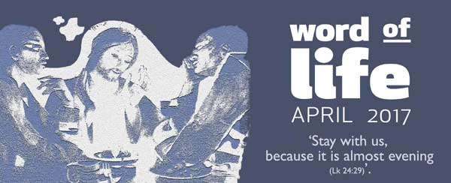
Like the disciples at Emmaus, we can invite Jesus to stay with us. He has transformed every pain into a chance to meet him and so find our pain transformed into love.
‘Stay with us, because it is almost evening’ (Luke 24:29).
This was an invitation two travellers made to a stranger, having met him on their way from Jerusalem to the village of Emmaus. The stranger had come upon them while they were ‘talking and discussing’ all that had recently happened in that city, and he seemed to be the only person to know nothing about it.
So the two of them welcomed him to walk with them, and they told him about ‘a prophet mighty in deed and word before God and all the people’ (Lk 24:19). They had put their trust in him, yet he had been handed over by the chief priests and the leaders of the people to the Romans, condemned to death and crucified. It was an immense tragedy, and they could make no sense of it.
As they walked, the stranger helped them understand the meaning of what had happened, based upon Scripture. It rekindled hope in their hearts.
When they reached Emmaus, they urged him to join them for supper: ‘Stay with us, because it is almost evening.’ While at table together, the stranger blessed the bread and shared it with them. This gesture opened their eyes to who he was: the man once crucified and dead was now risen!
The two of them immediately changed their plans. They went back to Jerusalem to find the other disciples and tell them the great news.
We too can be disillusioned, appalled, disheartened by a terrible feeling of powerlessness in the face of injustices done to the innocent and defenceless. Our own lives have their share of pain, uncertainty, darkness… How we would like to transform it all into peace, hope, light for ourselves and for others!
Do we want to meet Someone who can understand us to the core of our being, Someone who can shed light upon our journey through life?
Jesus, the God-man, freely accepted to experience the tunnel of pain as we do, to meet each of us in the depths of our situations. He felt physical pain, but he also felt inner pain: from betrayal by his friends to the point even of feeling forsaken by that very God he had always called Father (see Mt 27:46; Mk 15:34). Through his unshakeable faith in the love of God, he overcame such immense pain, entrusting himself once more to the Father (Lk 23:46), and from the Father he received new life.
Jesus has brought all of us onto this same path, and he wants to travel with us. In the April 1999 Focolare Word of Life, Chiara Lubich wrote, ‘He is there in anything that hurts us … Let's try to recognize Jesus in all the distress and the tough situations in life, in all darkness, in our personal misfortunes and those of others, and in the sufferings of the world around us. They are him because he has made them his own. It would be enough … to do something practical to lessen “his” suffering in the poor … for us to … find … a new fullness of life.’
A seven-year-old girl shared her experience: ‘I was very sad when my daddy was sent to prison. I loved Jesus in him, so when we went to visit, I didn’t cry in front of him.’
A young wife said: ‘I accompanied my husband, Robert, through the last months of his life, after the doctors gave him no hope of recovery. I never left him for a moment. Seeing him, I saw Jesus. Robert was on the cross, really on the cross.’
Their love for one another became a source of light for their friends, who were drawn to compete in solidarity, never letting up and spreading to many others, giving rise to an association for social development called Abbraccio Planetario (‘global embrace’).
‘What we experienced with Robert,’ said one of his friends, ‘inspired us to follow him on a real journey towards God. We often ask ourselves the meaning of suffering, illness and death. I believe everyone who had the gift of sharing a part of the journey alongside Robert now has a very clear answer.’
This month all Christians celebrate the mystery of Jesus’ death and resurrection. It is a chance to rekindle our faith in God’s love, which allows us to transform pain into love. Every detachment, separation, failure, and death itself, can become for us too, a source of light and peace.
Sure of God’s closeness to each of us, in any situation, let’s repeat with trust the disciples’ prayer at Emmaus, ‘Stay with us, because it is almost evening.’
Letizia Magri

