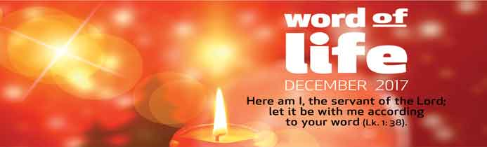
“Here am I, the servant of the Lord; let it be with me according to your word.’’
A young woman was in her house in Palestine, a distant, little known corner of the powerful Roman Empire. Suddenly, she received an unexpected and rather disturbing visitor: a messenger from God asking something of her and awaiting her reply. ‘’Rejoice!’’ the angel said to Mary. Then he revealed God’s abounding love for her inviting her to collaborate in fulfilling God’s plans for humanity.
With a sense of wonder and joy, Mary accepted the gift of this personal encounter with the Lord. She entrusted herself entirely to this yet unknown plan, because of her complete faith in the love of God. With her generous and wholehearted ‘’Here am I,” Mary put herself decisively at the service of God and of people, giving a shining example to all of how to accept God’s will.
“Here am I, the servant of the Lord; let it be with me according to your word.’’
Meditating on this Gospel passage, Chiara Lubich wrote, ‘’To fulfil his plans, God just needs people who surrender themselves to him as humbly and as readily as a servant. Mary is the true representative of humanity, whose destiny she took on. With this attitude, she gives God all the space he needs for his creative action. However, the term ‘servant of the Lord’ is not only an expression of humility, but also a title of nobility, given to great servants in salvation history like Abraham, Moses, David and the Prophets. Therefore, by using these words, Mary also affirms her greatness.’’ 1
‘’Here am I, the servant of the Lord; let it be with me according to your word’’.
We, too, can discover God’s presence in our lives and listen to the ‘’word’’ He says to us, as he asks us to fulfil, here and now, a part of his design of love for history. Our weakness and sense of inadequacy may hinder us. So let us believe the angel’s words, ‘’Nothing will be impossible with God’’ (Lk 1:37) and trust in God’s power more than in our own strength. This experience will free us from our limitations and from the presumption of being self-sufficient. We will find new energy and talents we did not know we had, allowing us to love in our turn.
A married couple shared their experience: ‘’Right at the start of our marriage, we opened our house to the families of children who were being treated in our city’s hospitals. Over the years, more than a hundred families came to our house, and we always tried to create a welcoming atmosphere for them. We often received providence, which helped us cover our expenses, but our priority was always to be open to welcoming people. Not long ago, we were unexpectedly given some money and decided to put it on one side, because we were sure it would be useful for somebody. In fact, soon afterwards another request arrived. It is all a game of love with God and our part is just to be ready and play along.”
‘’Here am I, the servant of the Lord; let it be with me according to your word.’’
We can be helped to live this phrase of the Gospel by what Chiara said about accepting the Word of God as Mary did: ‘’…being completely available, knowing that it is not merely a human word. As it is the Word of God, it contains a presence of Christ. So you can receive Christ, in His Word, within you and then, put it into practice actively and readily, moment by moment. If you do this, the world will once again see Christ walking through the streets of our cities. Christ in you, clothed like everyone else. Christ at work in offices, schools and the most varied places; Christ among all.’’2
Now that we are preparing for Christmas, let us find some time, as Mary did, to spend ‘’one on one’’ with the Lord, perhaps by reading a page of the Gospel. Let us try to recognize his voice in our conscience which will be enlightened by his Word. We will become more sensitive to the needs of the brothers and sisters we will meet. Let us ask ourselves, how can I be a presence of Jesus today? How can I contribute, there where I am, to making all people become one family?
Saying ‘‘Here am I’’ to God, will allow Him to sow peace around us and increase the joy in our hearts.
Letizia Magri
- “Don’t miss the chance.” By Chiara Lubich, “Citta Nuova” no. 25, 1981 p.40
- Ibid

