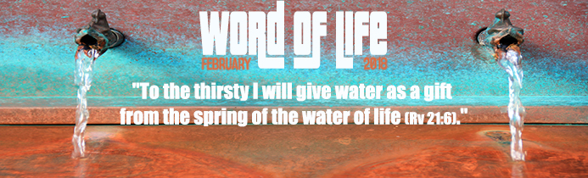
John of Patmos wrote the Book of Revelation to console and encourage the Christians of his time who were facing widespread persecution. His book is rich in symbolic imagery and reveals God’s view of history and its fulfilment at the end of time in his definitive victory over all evil. It celebrates a full and glorious point of arrival, God’s destiny for humanity. It is the promise of liberation from all suffering. God himself ‘will wipe every tear from their eyes… Death will be no more; mourning and crying and pain will be no more’ (Rv 21:4).
To the thirsty I will give water as a gift from the spring of the water of life.
The first signs of this final goal are already apparent to those who have sincerely begun to live their life searching for God and his Word that reveals his plans. They can be found by those thirsting for truth, justice, and fraternity. God sees this thirsting and searching positively, as a good start and he even promises to give us the spring of the water of life. The water God promises is given freely. It is not given only to those who hope to please God through their own efforts, but also to all those who feel the burden of their weakness and entrust themselves to his love, believing that they will be healed and will find the fullness of life and happiness. Let us ask ourselves then, for what do we thirst? Moreover, to which springs do we go to quench our thirst?
To the thirsty I will give water as a gift from the spring of the water of life.
Perhaps we are thirsting for acceptance, for a place in society, for our plans to work out… These aspirations, although legitimate in themselves, can push us towards the polluted wells of selfishness and towards an attitude of self-interest and even oppression of the weak. Populations suffering a shortage of fresh water wells, are acutely aware of the disastrous effects of the lack of this resource, which is indispensable for life and health. Yet, going deeper into our hearts, we find another kind of thirst that God himself has put there; the thirst to live our life as a gift we have received, and that must be shared. Let us then draw from the pure source of the Gospel, freeing ourselves from all the debris that may cover it, and allow ourselves to be transformed into fountains of generous, welcoming and freely given love for all, without stopping at the inevitable difficulties along the way.
To the thirsty I will give water as a gift from the spring of the water of life.
When Christians put the commandment of reciprocal love into practice, they allow God to intervene in a very special way as Chiara Lubich says:
‘Every time we try to live the Gospel, it is like drinking a drop of that living water. Every gesture of love for our neighbour is a sip of that water.
Yes, because that water, so precious and full of life, is special: it gushes forth every time we open our hearts to love everyone. God’s spring gives water in the measure that it is being fed – via its deep underground streams – by quenching the thirst of others through small and great acts of love. If we continue to love, this fountain of peace and life will give evermore abundant water, without ever drying up.
Jesus also revealed another secret to us, a kind of bottomless well from which we can draw: when two or three are united in his name, loving one another with his same love, he is in their midst. Doing so, we will feel free indeed, full of light, and streams of living water will flow from within us. It is Jesus’ own promise being fulfilled, because it is from him, present in our midst, that thirst-quenching water will well up for all eternity.’¹

Cf. C. Lubich, Word of Life, New City, March 2002, p 10-11

