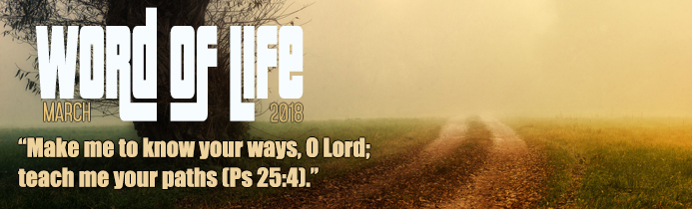
King David, who was also a prophet, wrote this psalm at a time when he felt weighed down by anguish and poverty and in danger from his enemies. He wanted to find a way out of his painful situation but realised he was completely unable to do so. Therefore, he looked up, with hope, towards the God of Israel, who had always protected his people, and implored him to come to his aid. This month’s Word of life draws our attention to the fact that he was asking to know the ways and paths of the Lord, to shed light on the choices he had to make, especially at difficult times.
Make me to know your ways, O Lord; teach me your paths.
Sometimes in life we too have to make decisive choices. It can be totally absorbing to have to do so and can make us think deeply about what our consciences suggest is the right way forward. It could be that we have many paths from which to choose and are uncertain about which is the best. At other times, we feel there is no path at all. Wanting to find a way ahead is a strong human need and so sometimes we ask help from those we consider our friends. Christian faith makes us become friends with God. He is a Father who loves us; he knows us through and through and wants to accompany us on our journey.
Every day, God invites us to set out freely on an adventure in which our compass is unselfish love for him and all his children. The ways and paths are opportunities to meet other travellers and find new goals that can be shared. Christians are never isolated individuals, but part of a people travelling towards the fulfilment of the plan of God the Father for humankind. Through all he said and did, Jesus revealed God’s plan to bring about universal fraternity, the civilisation of love.
Make me to know your ways, O Lord; teach me your paths.
The Lord’s ways can be daring and, at times, may seem too challenging for us, like rope bridges joining high rock faces. They challenge our selfish habits, our prejudices and false humility and instead, create opportunities for dialogue, encounter and commitment to the common good. Above all, they call for a love that is ever new and capable of forgiving, because it is founded on the rock of God’s love and faithfulness to us.
This ever-new love is essential if we are to build just and peaceful relationships among peoples and nations. Even the witness given by a simple kind deed, done with love, can give others the light to see their way forward.
At a meeting in Nigeria, when both children and adults were sharing their experiences of loving according to the Gospel, a little girl called Maya said, ‘Yesterday, when we were playing, a boy pushed me and I fell over. He said “sorry” and I forgave him.’ Those words touched the heart of a man whose father was killed by Boko Haram. ‘I looked at Maya. If a little girl like her can forgive, it means that I can do the same.’
Make me to know your ways, O Lord; teach me your paths.
If we want a sure guide on our journey, let’s remember that Jesus said, ‘I am the Way…’ (Jn 14: 6). When Chiara Lubich spoke to young people gathered in Santiago di Compostela during the 1989 World Youth Day, she encouraged them as follows: ‘By describing himself as “the Way”, Jesus was saying we must take the same way as he did. We could therefore say that the way Jesus followed has a name: it is love. The love that Jesus lived and brought on earth is special and unique. It is the same ardent love that burns in God... But who should we love? Our first duty of course, is to love God. Then, to love our neighbour, every neighbour… From the moment we wake up in the morning until we go to sleep at night, every relationship with our neighbour should be lived with this love. Whether we are at home, at university, at work, on a sports field, on holiday, in church or on the street, we should take advantage of every opportunity to love, seeing Jesus in our neighbours, neglecting no one, indeed, being the first to love… It means entering as far as possible into the minds and hearts of others, truly understanding their problems, needs and troubles – as well as their joys – so that we can share everything with them… In a way, we have to become that other person, like Jesus, who was God, became a man out of love. Then our neighbours will feel understood and supported because someone is helping them bear their burdens and pain and share in their joys. “Living the other person”, “living the others” – this is a great ideal, this is amazing.’
Letizia Magri

