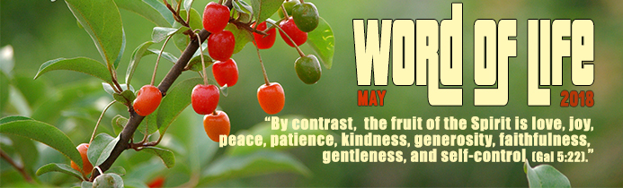
St Paul was writing to Christians in the region of Galatia, who had heard the proclamation of the Gospel from him. He scolded them for not understanding the meaning of Christian freedom. For the people of Israel, freedom was a gift from God who had brought them out of slavery in Egypt and led them to a new land, establishing a pact of mutual faithfulness with them. At the same time, Paul strongly affirmed that Christian freedom is a gift from Jesus. In fact, Jesus makes it possible for us, in Him and like Him, to become children of God who is Love. By imitating the Father as Jesus taught us¹ and showed us² through His life, we too can learn to have the same attitude of mercy towards everyone, and be at their service. For Paul, the apparent contradiction in ‘’freedom to serve’’ is possible through the gift of the Spirit that Jesus gave to humanity by his death on the cross. The Spirit gives us the strength to come out of the prison of our selfishness, which is burdened with divisions, injustices, betrayals, and violence. He leads us to true freedom.
"By contrast, the fruit of the Spirit is love, joy, peace, patience, kindness, generosity, faithfulness, gentleness, and self-control.”
Besides being a gift, Christian freedom is also a commitment. Above all, it is a commitment to welcome the Spirit into our hearts, making room for Him and recognizing His voice in us. Chiara Lubich wrote: […] “Above all, we must become more and more aware of the presence of the Holy Spirit in us. We have a great treasure in our innermost being, but are not sufficiently aware of it. […] To hear the voice of the Spirit and follow it, we must say no […] to temptation, rejecting its suggestions; and say yes to the tasks God has entrusted to us; yes to love for our neighbors; yes to the trials and difficulties we encounter… By doing so, the Holy Spirit will guide us and give our Christian life the savor, vigor, edge and brightness without which it cannot be authentic. Then, whoever is with us will notice that we are not only children of our natural family, but also children of God".³
In fact, the Spirit calls us to step aside from being the center of our concerns in order to be more receptive to others, to listen to them and share material and spiritual goods. He calls us to forgive or take care of the most varied people in the different situations of daily life. This attitude allows us to experience the characteristic fruit of the spirit: growth in our own humanity towards true freedom. This brings out and develops talents and resourcefulness in us that would have stayed buried and unknown had we continued living wrapped up in ourselves. Every action of ours is a not to be missed opportunity to say no to the slavery of selfishness and yes to the freedom of loving.
"By contrast, the fruit of the Spirit is love, joy, peace, patience, kindness, generosity, faithfulness, gentleness, and self-control.”
Those who accept the work of the Spirit in their hearts also contribute towards building positive human relations through their daily activities, at home and in society. Carlo Colombino, a businessperson, husband and father, owns a company in northern Italy. Out of 60 employees, around a quarter are not Italian and some of them have had traumatic past experiences. He told the journalist who interviewed him, "Even the workplace can and should facilitate their integration. Our work includes quarrying and recycling construction materials, and I have responsibilities towards the environment and the area where I live. Some years ago, the economic crisis hit us hard: should I save the business or the employees? We made some people redundant, talking it over with them and finding the least painful solutions. It was a dramatic experience with sleepless nights. I can do my job either well or less well. I try to do it as best I can. I believe in the positive influence of ideas.
A business focused only on turnover and figures will not last long. People must be at the center of all we do. I believe in God and am convinced that harmonizing business and solidarity is not a dream⁵ Let’s courageously set in motion our personal call to freedom, in the environment where we live and work. This will allow the Spirit to touch and renew the lives of many people around us, and move history towards a future of “joy, peace, patience, kindness...”
Letizia Magri
1 Mt 5: 43-48; Lk 6:36
2 Mk 10:45
3 Cfr. C. Lubich, We have a Treasure, New City, 44 (2000), 10, p. 7.

