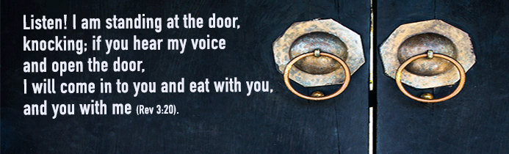
Listen! I am standing at the door, knocking; if you hear my voice and open the door,
I will come in to you and eat with you, and you with me. (Rev. 3:20).
We may often hear a knock at the door. It might be someone with a delivery or our neighbour or one of our children’s friends. Sometimes it may be a stranger. What do they want? Is it a good idea to open the door and let in someone who we don’t know?
This Word of God, taken from the Book of Revelation, invites us to welcome an unexpected guest.
This book is very informative for Christians. The author, on this occasion, was writing to the church in Laodicea. He wrote in the name of the Lord Jesus who had died and risen from the dead out of love for every human being. The authoritative guidance he gave derived from this love. He praised the community, corrected them and asked them to be open to the powerful help that the Lord himself was prepared to give, provided they were ready to recognise his voice and “open the door.”
Listen! I am standing at the door, knocking; if you hear my voice and open the door,
I will come in to you and eat with you, and you with me.
It’s the same today. Now too, the whole Christian community is asked to overcome fear, division and a false sense of security, to welcome the coming of Jesus. In fact, he comes to us every day in different “guises”. These might be our daily sufferings, the difficulties we face in being faithful to the Gospel, or challenges concerning important choices we make in life. Above all, he comes to us in the people we meet around us.
It is also an invitation to each of us to “spend time” with Jesus in a personal conversation, as you would with a friend during a quiet evening, sitting at table together. That is the best time for a conversation that calls for openness and listening.
We need to “shut out” all external noise if we want to recognise and hear his voice, his Spirit, who can help us break through our fear and open the door of our heart.
Chiara Lubich wrote about her own experience: “We must silence everything within us in order to discover the voice of the Spirit. We need to draw it out as if we were extracting a diamond from mud: polish it up, display it and share it with other people at the right moment, because it is Love and Love is meant to be given. It is like fire, which burns when in contact with straw or other material. If it does not do this, it dies out. Love must grow in us and overflow.”
Pope Francis has said that: “The Holy Spirit is a gift … He enters us and makes us fruitful, so that we can then give him to others. … The Holy Spirit shifts us from our ‘I’ in order to open us up to the ‘we’ of the community: receiving in order to give. We are not at the centre: we are an instrument of that gift for others.”
Listen! I am standing at the door, knocking; if you hear my voice and open the door,
I will come in to you and eat with you, and you with me.
By living mutual love which is characteristic of the Gospel, Christians can be witnesses to the presence of God in history.
In an area where there are many migrants, someone heard a ‘knock at her door’. This is Delia’s story: “It was a hot Sunday afternoon and quite a few mothers and children were sitting on the pavement outside my café. The children were crying because they were hungry. I asked them all to come in and said that the children’s meals would be free. Their mothers were embarrassed because they had no money, but I was determined to feed them and they accepted my offer. That was the start of it all and now my place has become the migrants’ café, most of whom are Muslim. Many of them call me “Mummy Africa”. The people who used to be my clients gradually stopped coming. So, the room where the older people played board games has now become the children’s room where they can write and play and there is a small changing area for the babies, so that their mothers can rest. Sometimes it becomes a classroom for Italian lessons.
I didn’t make a specific choice to change my customers – I just couldn’t ignore the migrants. Thanks to them I have met many people and organisations that support me and help me keep going. If I were to start over, I would do the same thing again. For me what matters is TO GIVE!”
All of us are invited to welcome the Lord who knocks at our door so that together with him we can go out towards our neighbours.
The Lord’s presence in our life will grow stronger.
Letizia Magri

POPE FRANCIS, General Audience 6 June 2018.

