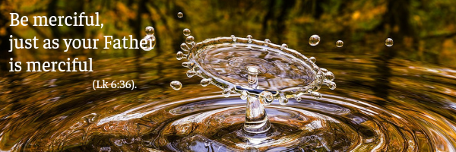

St Luke’s gospel tells us that, after proclaiming the beatitudes to his disciples, Jesus then invited his followers to love every person as a brother or sister, even those considered to be enemies. This invitation was almost revolutionary at the time but Jesus is very clear in stating that we are all brothers and sisters because we have one Father who always seeks out his children. God the Father wants to relate to us: he reminds us of our responsibilities but at the same time his love heals, nourishes and takes care of us. His attitude is motherly, compassionate and tender. This is the mercy of God who reaches out personally to every human being in their weakness and fragility. In fact, God prefers those who are excluded, rejected and on the periphery of society. Mercy is a love that fills our hearts and then flows out to others, to neighbours as well as strangers, to society around us. Since we are children of God, we can imitate and resemble him in his characteristic way of loving - by accepting and welcoming others and knowing how to wait until others are ready to accept this love, it is the right time for them.
Be merciful, just as your Father is merciful.

nfortunately, in our personal and social lives we ​​breathe an atmosphere of growing hostility and competition, of mutual suspicion, judgment and fear of others. Grudges accumulate and lead to conflicts and wars. As Christians, we can give a clear witness of refusing to be swept along by these negative attitudes. We can try to be free from ourselves and from outside circumstances, and begin to rebuild the weakened or broken bonds in our family, workplace, parish community or political party.
If we have hurt someone, let’s have the courage to ask forgiveness and start again. It is an act of great dignity. If someone has truly offended us, let’s try to forgive them and make room for that person once more in our heart, so that they too can heal the wound. But what is forgiveness? “Forgiveness is not forgetfulness [...] it is not weakness, [...] it does not mean taking serious matters very lightly, or considering as good what is in fact bad, [...] it is not indifference. Forgiveness is a clear-sighted act of will, and thus a free act that welcomes the other as they are, despite the wrong done to us, just as God welcomes us sinners, despite our faults.
Forgiveness means not reacting to wrongs done with more wrongs, but doing what St Paul says, ‘Do not be overcome by evil, but overcome evil with good.’" Such openheartedness cannot be improvised. It is a daily conquest, a constant growing in our identity as children of God. Above all, it is a gift from the Father that we can and must ask from him.
Be merciful, just as your Father is merciful

A young woman from the Philippines told us her story, "I was only eleven when my father was killed, but justice was left undone because we were poor. When I grew up, I studied law because I wanted justice for my father's death. But God had another plan for me. A colleague invited me to meet people who were seriously committed to living the Gospel. I started to live in the same way. One day I asked Jesus to teach me how to live his words ‘Love your enemies’ in a real way because I still felt hatred within me for the men who had killed my father. The next day, at work, I met the head of that criminal group. I greeted him with a smile and asked about his family.
He was astonished by this and I was even more surprised at what I had done. The hatred within me started breaking down and was transformed into love. However, that was only the first step: love is creative! I thought that every member of the criminal group had to receive our forgiveness. My brother and I visited them to re-establish a relationship and bear witness that God loves them! One man asked our forgiveness for what he had done as well as prayers for himself and his family."

Letizia Magri

Rom: 12:21
Cf. C. Lubich, Costruire sulla roccia, [Building on rock] Città Nuova, Rome 1993, p.56.
Cf. Mt 5:44; Lk 6:27.

