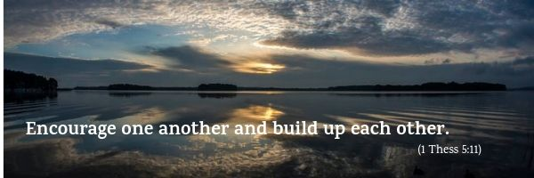
9
St Paul was writing to the Christian community he founded in Thessalonica. He was not able to visit there anymore, having had to escape from the city due to serious difficulties and persecution. However, through his letters, he continued to accompany the people with love and indeed he praised them for their constancy and perseverance in faith. They had become exemplary witnesses!
Paul knew that the community was asking very deep and existential questions: what happens to us after we die? If the Lord is coming back soon, how can we prepare ourselves adequately for his final coming?
Paul did not answer them with norms they should follow but made a profession of faith instead: Jesus gave his life out of love for all humanity and is risen from the dead, thus opening the path to Life for all people.
To prepare for his return, Paul advised them to live the Gospel in everyday life, continuing to work honestly and build a sense of family in the community.

Encourage one another and build up each other.

Paul had experienced this first-hand: the Gospel makes the seed of goodness that God has placed in the human heart sprout and grow.
This is a seed of hope, which grows through our personal daily contact with God's love and bears fruit in mutual love. It stimulates us to resist the bad seeds of individualism and indifference that cause isolation and conflict, and, instead, to share one another's burdens and encourage each other.
This is a simple word of life that we can all understand and put into practice; but it can revolutionize our personal and social relationships.
It is a valuable piece of advice that helps us rediscover the fundamental truth of being brothers and sisters which underlies many cultures. This is expressed by the principle Ubuntu in Bantu philosophy: "I am what I am because of who we all are".
This thought guided the great Methodist leader, Nelson Mandela, in his political work in South Africa. He said, "Ubuntu doesn't mean that people should not think of themselves, but rather they should ask, ‘Do I want to help the community around me?’”. Mandela’s consistent and courageous work brought about historic change in his country and a great step forward in civilization.

Encourage one another and build up each other.

How can we live this word of life?
“By trying to grow in mutual love in our families, in our work environment, in our communities, church organisations, parishes and so on. This word of life asks us to have an ever greater charity that knows how to overcome the lack of generosity and the various barriers that derive from the subtle selfishness within us all. It is enough to think of particular aspects of charity, like tolerance, understanding, mutual acceptance, patience, willingness to serve, mercy towards the real or presumed shortcomings of our neighbour, sharing material goods, etc. in order to discover many opportunities to live it.
Clearly, then, if there is an atmosphere of mutual love in our community, its warmth will inevitably spread to others. Even those who do not yet know the Christian life will be attracted and easily, almost without realizing it, they will become involved and feel part of this family.”

Encourage one another and build up each other

This spirit is what led a group of doctors, nurses, psychologists and other medical specialists, in Palermo, Italy, to help disadvantaged people in their city. This is what they said: "We are a group of Christian doctors and health workers from various Churches. The words of the Gospel urge us to see all people as brothers or sisters, especially those who are ill but have no access to adequate treatment. Our patients include people who have very serious illnesses as well as some who are addicted to gambling and the internet. We see these people in a professional capacity in our own workplaces, thus enhancing the potential of the clinics already present in the area. To maintain contact and share the various needs, we have created a WhatsApp chat, a Facebook page and a network of email addresses.
Although it started recently, our group is already very active. We work a great deal with the immigrant population, in particular the Ghanaian Adventist community in Palermo who are a large and joyful group. Our contact with them enables us to experience the joy of helping one another as brothers and sisters who are children of the one Father."

Letizia Magri

From "Experience Ubuntu”; interview by Tim Modise, May 24, 2006. Origin: https://le-citazioni.it/autori/nelson-mandela/.
C. Lubich, Word of Life September 2004.

