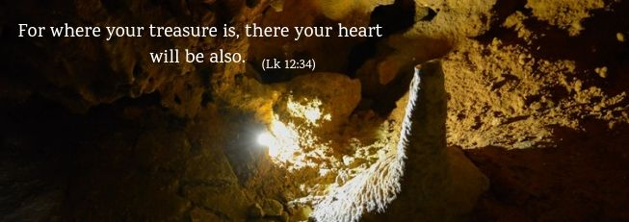

The "heart" represents the hidden, deepest and most intimate part of ourselves and the very source of our lives. The “treasure” represents whatever has most value and gives us security both today and in the future. Our "heart" also represents our values, the source of the choices we make; it is the secret place where the meaning of life itself is at stake. What is most important for us? What is our "treasure" for which we are ready to leave all else behind?

Western consumer society encourages us to accumulate material goods, to concentrate on our own needs and not bother about those of others. This is driven by the pursuit of personal well-being and efficiency. Yet St Luke, who wrote his Gospel in a very different cultural context, presents these words of Jesus as a decisive and universal teaching for men and women of all times and all places.

**For where your treasure is, there your heart will be also**

Luke's Gospel strongly emphasises the need for Jesus’ disciples to make a radical, definitive and characteristic choice. God the Father is the true good, who must occupy a Christian’s whole heart, following the example of Jesus himself. This exclusive choice brings with it a trusting abandonment to God’s love and the chance of becoming truly "rich" because the children of God are heirs to his kingdom.

It is a question of freedom which means not letting ourselves be possessed by material goods, but really having control over them. Material wealth, in fact, can occupy our "heart" and generate a growing anxiety to possess more, which can become real dependence. Instead, almsgiving, to which we are exhorted in this passage of the Gospel, is a matter of justice, dictated by mercy, which lightens the "heart" and opens us up to fraternal equality.

Every Christian personally, and the whole community of believers, can experience true freedom through sharing both material and spiritual goods with those who need them. This is the Christian lifestyle that bears witness to real trust in the Father and lays solid foundations for the civilization of love.

**For where your treasure is, there your heart will be also**

To free us from the slavery of having, Chiara Lubich made an enlightening suggestion: "Why does Jesus insist so much on detachment from goods, to the point of making it an indispensable condition for being able to follow him? Because the first treasure in life, our real wealth, is him! … He wants us to be free, with our souls unburdened by any attachment or worry, so that we can truly love him with all our heart, mind and strength. … He asks us to renounce our possessions also because he wants us to be open to others… The simplest way to "renounce" is to "give".

We can give to God by loving him. We can show our love by loving our brothers and sisters, being ready to risk everything for them. Even if we do not realise, we have much wealth to share: we have love in our hearts to give, friendship to express and joy to communicate. We have time to use for other people, prayers to offer, inner riches to share. Sometimes we have things such as books, clothes, cars, money... Let’s give them to others and not reason that they might be useful on such and such an occasion. Everything can be useful, but in the meantime, by giving in to these ideas, our hearts can become full of attachments which, in turn, create new needs within us. No, let’s try to keep only what we need. Let’s be careful not to lose Jesus because of some money we have set aside, because of something we can do without". [1]

Marisa and Agostino, who have been married for thirty-four years, told us their experience, ‘After eight years of marriage, everything was going well for us: the house and our jobs were just as we wanted them. But then we were asked whether we could move from Italy to a Latin American country, to support a young Christian community. Among the thousands of different voices we heard within that expressed concern about an unknown future and the comments of people who told us we were crazy, both of us were aware of one voice in particular that gave us a great peace. It was Jesus who was saying, "Come, follow me." So we did. We found ourselves in a completely different environment from what we were used to. Although we had much less than we had before, we felt that we received many other things in exchange, such as wonderful relationships with many people.

The experience of God’s providence was also very strong. One evening we had organized a small party and each family was going to bring typical dishes for the meal. We had just returned from Italy with a big piece of Parmesan cheese. We felt torn between wanting to share a part of it with the other families and the thought that there would be little left for us, but we remembered Jesus' words, "Give, and it will be given to you." (Lk 6:38). We looked at each other and said: we’ve left our country, our jobs and our relatives, and now we are attaching ourselves to a piece of cheese! So we cut a lump of cheese and took it with us. Two days later the doorbell rang; it was a tourist that we didn't know, a friend of some friends of ours, and he gave us a package from them. We opened it and found a big piece of Parmesan cheese. Jesus’ promise, "...a good measure, pressed down, shaken together, running over, will be put into your lap" is really true.’

Letizia Magri

1. C. Lubich, *Word of Life* September 2004.