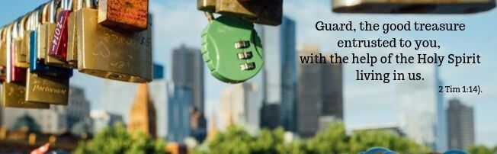
Paul the apostle is writing to Timothy, his "son in faith", with whom he shared his evangelizing activity and to whom he entrusted the community in Ephesus.
Paul feels that the time of his death is drawing close and he encourages Timothy in this demanding task of leadership. Timothy, in fact, has received a "precious gift “ that is, the content of the Christian faith as passed on by the apostles and he, in turn, is responsible for faithfully communicating it to future generations.
For Paul this means protecting and revealing the beauty of the gift received as well as being willing to give his life to spread the good news that is the Gospel.

Guard, the good treasure entrusted to you, with the help of the Holy Spirit living in us.

Paul and Timothy received the Holy Spirit as light and guarantee for their irreplaceable task as pastors and evangelizers. Through their witness and that of their successors, the proclamation of the Gospel has come down to us.
In the same way, every Christian has a "mission" in his or her own social and religious community: to build a united family, to educate young people, to engage in politics and work, to care for vulnerable people, to enlighten culture and art with the wisdom of the Gospel lived, to consecrate his or her life to God for the service of others.
Indeed, according to the words of Pope Francis to young people, "…every man and woman is a mission." We always have the opportunity to consciously renew our commitment to witnessing to our faith, with our hearts filled with evangelical love that generates welcome, encounter and dialogue.

Guard, the good treasure entrusted to you, with the help of the Holy Spirit living in us.

Every Christian is a "temple" of the Holy Spirit. This enables us to discover and preserve the "precious gifts" entrusted to us, to make them grow and put them at the service of other people. The first of these "treasures" is faith in the Lord Jesus. We Christians need to awaken this and nourish it with prayer, and then communicate it through the witness of charity.
A recently ordained priest told us: "I have been asked to minister to and care for the faithful in a large Catholic parish in a city in Brazil. The social environment is very difficult and often the people I meet do not have a clear religious identity; that is why they participate both in the Mass and in other ancient traditional ceremonies. I know that I am responsible for transmitting the Christian faith in fidelity to the Gospel, but I also want everyone to feel welcomed in the parish. I thought that, to enhance the cultural roots of these people, the celebration of Mass could be more festive and we could use musical instruments typical of their cultures. It is a demanding challenge, but one that makes everyone happy because, instead of dividing the community, it unites us in what we have in common: faith in the God who gives us joy."

Guard, the good treasure entrusted to you, with the help of the Holy Spirit living in us.

Another priceless treasure that we have received from Jesus himself is his word; it is the word of God. Chiara Lubich wrote: This gift "demands great responsibility from us…God has given us his word so that we might make it bear fruit. He wants it to transform our lives and all we do in the world... How, then, will we live this month’s word of life? By loving the word of God, trying to know it better and by putting it into practice with always greater generosity, so that it really becomes the basic nourishment of our spiritual life, our inner teacher, the guide of our conscience, the unshakable point of reference for all our choices and actions. At times, we may feel bewildered and confused because everything seems to become relative and unclear. By living the word of God we will not only be strengthened against this grave danger but, according to Jesus’ words (cf. Mt 5:15-16), we will become shining lamps, which with their light will also help others to find their way on the right path".

1Tim 1:2
Pope Francis. Message for World Mission Day 2018
Chiara Lubich. Commentary on word of life Oct 1991

